Portable Electroluminescence Measurement System

PELMS 2023.S1

Contents

PELMS Setup 3

PCCS (Portable Computing & Camera System) Setup 3

CRS (Current Regulator System) Setup 5

PELMS Operation 8

PELMS Components 10

PCCS Components 10

CRS Components 10

# PELMS Setup

## PCCS (Portable Computing & Camera System) Setup

1. Connect antenna to the RF LINX TX module.

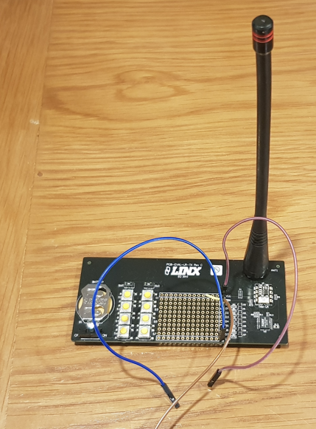

1. Connect RF LINX TX module to unpowered Raspberry Pi as follows:

* RF LINX TX (Vcc) – Purple Wire – Raspberry Pi (3v3) Pin 1
* RF LINK TX (Data D0) – Brown Wire – Raspberry Pi (GPIO4) Pin 4
* RF LINK TX (GND) – Blue Wire – Raspberry Pi (GND) Pin 5)

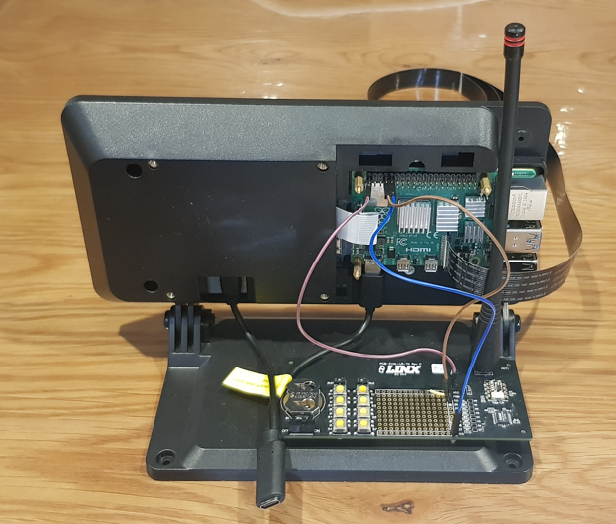 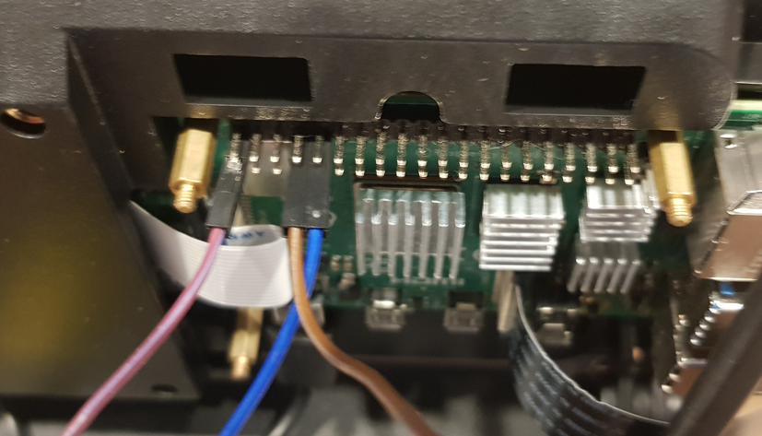

1. Switch RF LINX TX module to on.
2. Attach Camera as follows:

* Lift little thing
* Attach ribbon cable.
* Close little thing

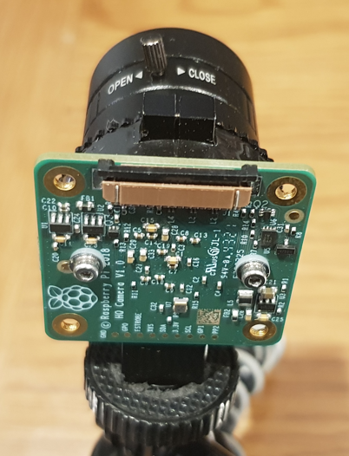

1. Attach the Raspberry Pi Power Supply – when it boots displays will come on.

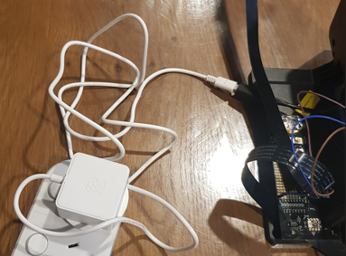 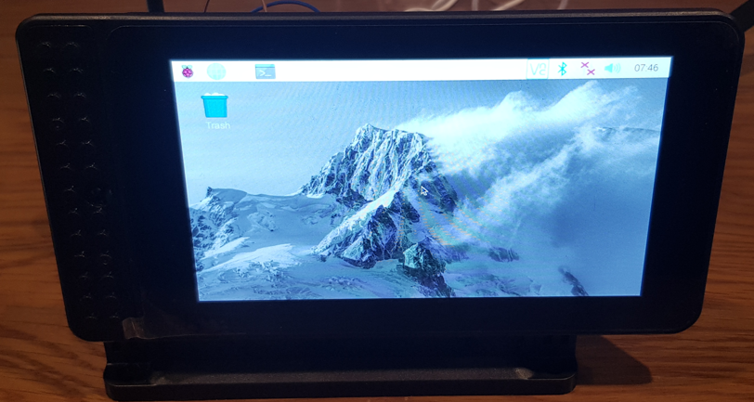

1. Attach keyboard.

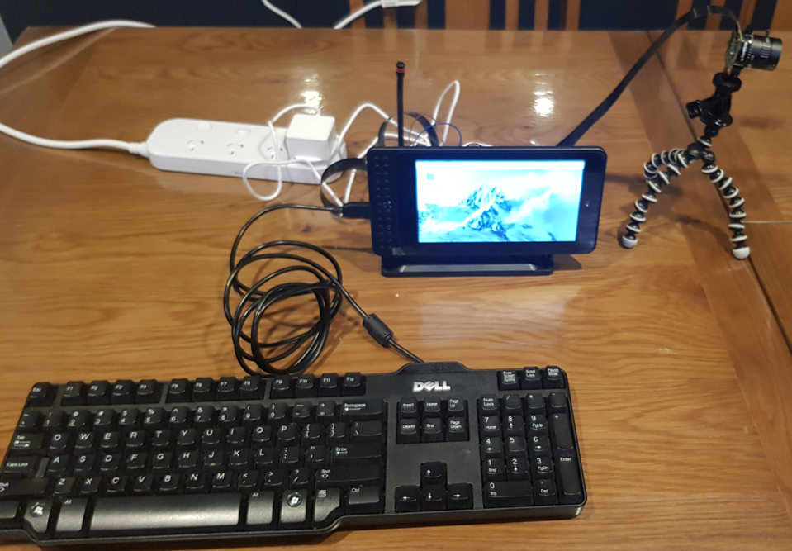

## CRS (Current Regulator System) Setup

1. Attach the antenna.

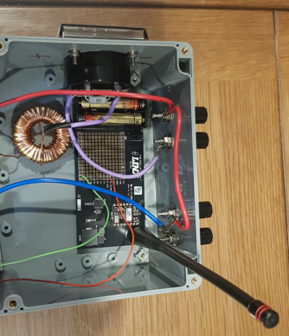

1. Switch the RF LINX TX to ON.

1. Make sure the system is off and attach the power source.

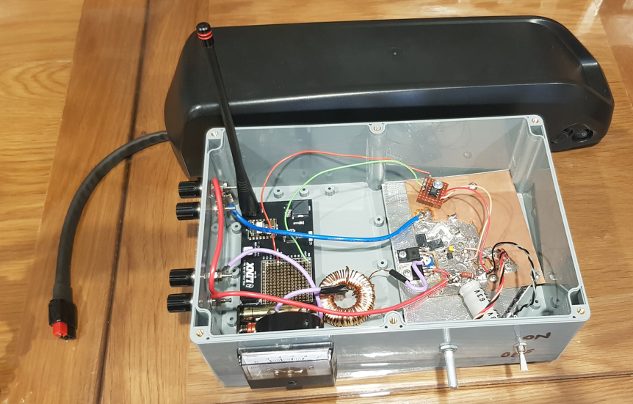

1. Connect to Solar Panel.

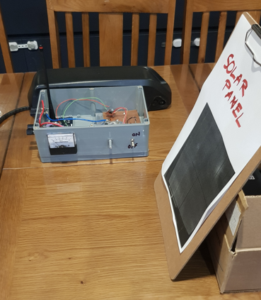

1. Turn on.

# PELMS Operation

1. Position the camera.

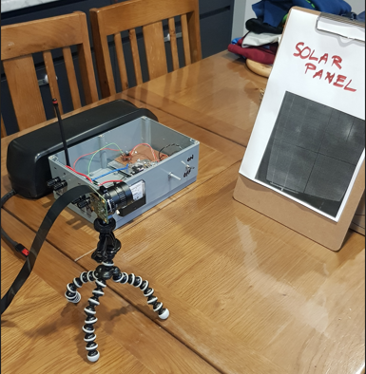

1. Turn the Current Regulator on.
2. On the touch screen, do the following:

* Select Terminal
* In the terminal type the following:

cd ~Portable EL

/bin/python “/home/portabeel/Portable EL/GUI_v2.0.py”

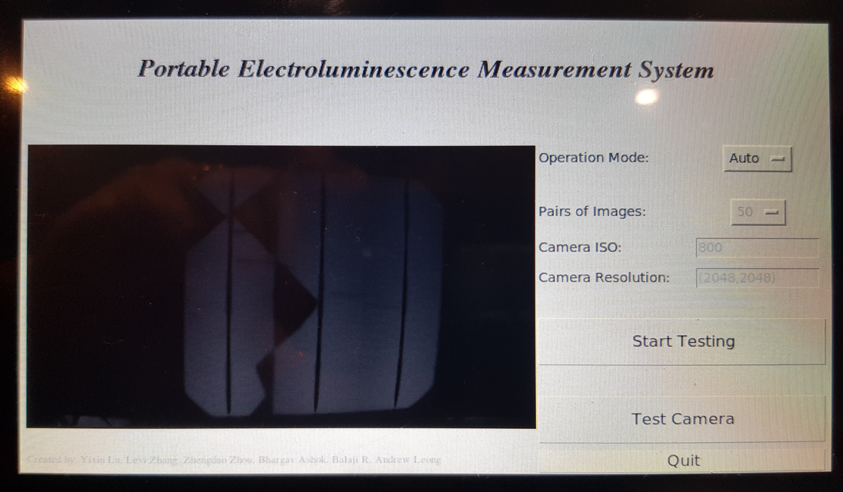

1. Click on the Test Camera and adjust the camera position.
2. Click on the Start Testing.

# PELMS System Description

The Portable Electroluminescence Measuemernt system is composed of 2 systems. The Portable Camera and Computing system and the Current Regulation system. The major components interaction of each system is shown in Figure 1 below.

## PCCS Components

|  |  |
| --- | --- |
| Raspberry Pi |  |
| Touch Screen |  |
| RF TX module |  |
| Camera |  |

## CRS Components

|  |  |
| --- | --- |
| Power Source |  |
| RF RX module |  |
| Current Regulator Control Circuit |  |
| PV Panel |  |